Paulius Zabinskas
Date: 07/02/2023
ID: 20120267

Assignment Report:
- Problem Statement:
The assignment problem is to read a string, string read must contain integers, consist of length 3-20 characters. Using stack Data Structure transform infix notation to postfix notation. Then, evaluate the postfix notation using stack again, return double value.
- Analysis and Design Notes:
The methods I will need:
Methods | Functionality
Read Input | Read in input. While input contains a letter, or is shorter than 3 characters, or longer than 20 characters, ask again for valid input.
Precedence | When reading operation symbols, return an integer of precedence to measure what operation should be performed first.
Infix To Postfix | Build a new string using stack data structure. Logic is defined in assignment notes. Precedence method will be needed.
Evaluate Postfix | Evaluation of postfix expression. Logic is defined in in assignment notes. Perform operation method will be used.
Perform Operation | When two integers are read, use following operator on numbers.

- Code:
- import java.util.Scanner;
public class Main {
public static void main(String[] args) {
String infix = readInput();
String postfix = infixToPostfix(infix);
System.out.println("Infix Expression: " + infix + "\nPostfix Expression: " + postfix);
System.out.println("The Value: "+ evaluatePostfix(postfix));
}
// read input
// try to get rid of all invalid inputs here
public static String readInput() {
Scanner sc = new Scanner(System.in);
System.out.println("Enter Infix Expression");
String uInput = sc.nextLine(); // Read user input
// check if input length is 3-20 chars
while ((uInput.length() < 3) || (uInput.length() > 20)) {
System.out.println("Invalid length of the input. Input must be between 3 - 20");
uInput = sc.nextLine();
}
// Check if inputs are characters
for (int i = 0; i < uInput.length(); i++) {
char ch = uInput.charAt(i);
if (Character.isAlphabetic(ch)) {
System.out.println("Invalid Input. Input Must Be Integers Only");
uInput = sc.nextLine();
}
}
// when done, return input
return uInput;
}
// decide on what operation has higher order
public static int precedence(char ch) {
switch (ch) {
case '+':
case '-':
return 1;
case '*':
case '/':
return 2;
case '^':
return 3;
}
return -1;
}
// using input, pass it to the satck in a way described in the assignment
public static String infixToPostfix(String expression) {
ArrayStack stack = new ArrayStack();
StringBuilder outputString = new StringBuilder();
// for length of expression
for (int i = 0; i < expression.length(); i++) {
// @ char i
char ch = expression.charAt(i);
// if char is digit
if (Character.isDigit(ch)) {
// push to stack
outputString.append(ch);
} else if (ch == '(') {
// '(' could just continue
// must stop at ')'
} else if (ch == ')') {
// check if stack is not empty
while (!stack.isEmpty()) {
outputString.append(stack.pop());
}
if (!stack.isEmpty()) {
return null;
} else {
stack.pop();
}
} else {
// while current ch precedence is lower than on the stack, then append the string
while (!stack.isEmpty() && precedence(ch) <= precedence((Character) stack.top())) {
outputString.append(stack.pop());
}
// if current precedence is higher, just push on top of the stack
stack.push(ch);
}
}
// append everything else
while (!stack.isEmpty()) {
outputString.append(stack.pop().toString());
}
return outputString.toString();
}
public static double evaluatePostfix(String expression) {
ArrayStack stack = new ArrayStack();
// the expression will be without of '(,)'
// also, notation will be:
// in a mirror reflection, last in first out
for (int i = 0; i < expression.length();i++){
char ch = expression.charAt(i);
if(Character.isDigit(ch)){
// pass a value to stack
stack.push((double)Character.getNumericValue(ch));
}
else {
double op1 = (double)stack.pop();
double op2 = (double)stack.pop();
// The stack inverts operations.
// So we need to perform operation on operand2
double result = performOperation(op2, op1, ch);
stack.push(result);
}
}
return (double)stack.top();
}
// perform operations
public static double performOperation(double operand1, double operand2, char operation){
switch (operation) {
case '+':
return operand1 + operand2;
case '-':
return operand1 - operand2;
case '*':
return operand1 * operand2;
case '/':
return operand1 / operand2;
case '^':
return Math.pow(operand1, operand2);
}
return 0;
}
}

- Testing:
Testing: | Result:
Invalid input: | - If input values will contain letters, length won’t be between 3-20, then will be asked to pass new input.
Invalid input: | 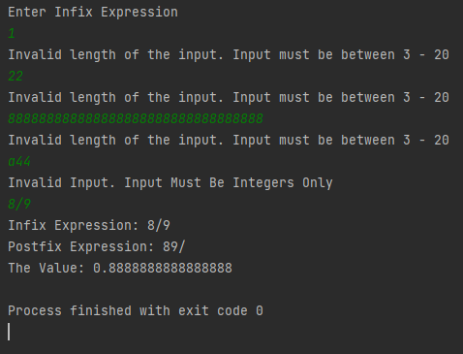
Infix To Postfix | - Output string should be containing 2 digits, operation. Then it may contain 1 or 2 digits, operation.
 | 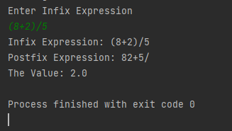 | 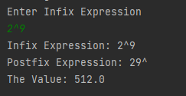
Symbols are interpreted correctly. | I expect the mathematical operations to be interpreted correctly.
 | 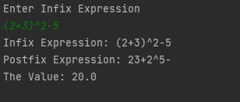

- Challenges:
The Infix to Postfix method functionality, logic implementation was difficult and time consuming.

